Saving our World
An educational drama-presentation on the environment and species loss.
Written by Sarah K Kilou in 2011 for One World Week
Updated in 2020 by S. Hirom, OWW

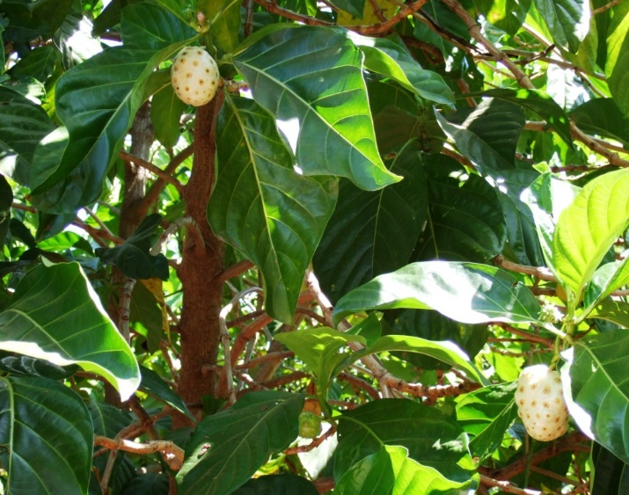 (photo: S.Hirom)

‘Noni’- a tropical forest plant being tested for cancer treatment properties

This drama-presentation focuses on the theme of ‘stewardship’ and the duty of humans to protect the world in which we live.

You will need:

The presentation covers the following themes:
- Showing an awareness of climate change.
- Protecting the wide diversity of animals and plants on the planet.
- The ways in which we can deal fairly with one another.

Suitable for:
- Children at Key Stage 2 and above
- Faith / multi-faith groups
- OWW events

- A cast of 4 required, with a chorus.
- 3 large banners:
‘Save our Rainforest
‘Save Endangered Species’
‘Climate Change’

Optional:
- Music (Latin American)
- Rainmaker / instruments to evoke
the rainforest
- Music /pictures to refer to recent climate change- enhanced event

Follow-up work

You could follow-up a performance of the play by exploring the following questions:
- Which natural resources do we extract from the rainforest?
- What methods are currently being used to extract these materials more sustainably?
- What action(s) can you take to help limit the destruction caused by climate change? Download OWW’s ‘Environmental Pledges’ online resource for more ideas. Create a pledge tree and share with the whole school.
- Which animals are currently on the ‘endangered’ and ‘vulnerable’ list? In what ways can you become involved in ensuring their continuing survival?
- Which groups are actively involved in the protection of endangered plants? Research and present findings for a presentation.
- Which animals and birds that became extinct in the UK are now being reintroduced- research how it is being done.

Some useful websites:

- The Rainforest Foundation UK: http://www.rainforestfoundationuk.org/
- Survival International: http://www.survivalinternational.org/
- Rainforest Concern: http://www.rainforestconcern.org/
- Mongabay.com: http://rainforests.mongabay.com/
- Coinet - about making the world a better place: http://www.coinet.org.uk/
- Climate outreach - communicating climate change: https://climateoutreach.org/

Saving Our World
Scene 1
(Background music from Latin America)
(Enter 2 actors holding banner ‘Save our Rainforest’)(2 actors in the background to use Rainmakers or other percussion instrument(s) to evoke the Amazon Rainforest)
A: What is this place? It’s so wild and wet and I can hardly see in front of me with all these trees and bushes.
B: What’s the matter with you? Don’t you know that we are in ‘the lungs of our planet’? This is the Amazon Rainforest and it recycles about 20% of the oxygen for our whole planet. It is the largest and densest forest in the world. If it were a country it would be the ninth largest on the earth.
C: Well why are we here then? I still do not see what is so special about it?
D: Don’t you realise what is happening here? There are 750 types of trees and 1,500 other plants making the rainforest the home to more than half the world’s plants. Maybe one of these plants could be a cure for cancer?
C: Why don’t they find it then?
B: Maybe they could but every year 2.7 billion acres of rainforest are burned.
C: Why?
B: Well, to create space for crops, and livestock.
D: Yeah and where do you think a lot of our timber comes from? The rainforest of course!
A: Surely that affects everything.
B: Yes. Losing all that rainforest will cause the climate to heat up and get hotter. Plants and animals will no longer be able to live freely in the forest and we will watch them disappear.
A: I thought we were supposed to be looking after our planet?
B: So did I! If this keeps happening, we will never find a cure for cancer.
Chorus: How can we stop this? How can we protect our planet?
D: Well, that’s obvious – we need to be better stewards, don’t we!
C: Oh right... stewardship. What does that mean exactly?
D: Stewardship means protecting or looking after something. All of our world’s major religions feel that it is our duty to look after the world in which we live, as God gave people responsibility. This responsibility means that we must be carers for our world and treat it with respect.
(Scene 1 continues on page 4)
B: Yeah, the world is being damaged by the way that we live our lives. Animals, plants and human beings are suffering. (B turns to the audience) We are going to look at some of the ways that we have abused the trust that we have been given.

Scene 2
(Enter 2 actors holding banner stating ‘Save Endangered Species’)
B: Do you know that there are more than 3,000 animal species endangered worldwide?
A: Why is that? I thought that it was important to look after animals so that we could all enjoy their beauty.
B: So did I but not everybody thinks like us. By the time our children have grown up, some animals will no longer be here at all. You know that orangutan that you like so much?
A: Yes what about it?
B: That’s a threatened species and unless people show they care they’ll soon be gone.
C: What’s the problem? Why are they endangered?
D: Some species face a lot of problems. Because of carbon dioxide emissions, a gas that goes into the air from all our factories and cars, the earth is getting hotter and the climate is changing. Some animals cannot survive in these conditions.
C: I read that poachers are a big threat. They hunt down animals and sell their skins and meat. This should be stopped. Who wants to wear someone else’s skin?
D: Yes and people are greedy and keep cutting down habitats for logging, and burning trees to create huge cattle ranches and to grow crops to feed humans and farm animals.
A: Why do we need such massive cattle ranches anyway? Do we really need to eat that much meat?
B: Well, all this demand for meat and wood is driven by some of the richest countries on our planet, hundreds of miles away from this rainforest, NOT by the people who are indigenous, or native, to the Amazon rainforest.
C: Yeah, in fact, these indigenous peoples have been living as hunter gatherers in harmony with nature for hundreds of years – it is not only certain animal species that are under threat, but the home and way of life of these people.
A: I guess the lives of the people and the animals that live in this part of the world are interlinked – what right does anybody have to threaten their way of life?
Chorus: How can we stop this? How can we protect the rainforest and save it for the future?

Scene 3
(Enter 2 actors holding banner stating ‘Climate Change ’)
(Background music or pictures can be of recent events; e.g. Hurricane, flooding - always feature recent events as these will already be in the minds of the audience)
A: I really don’t see how we can be responsible for all these disasters that are happening.
B: Everyone has a responsibility. Because of the way we are using our planet we are altering what is happening on it.
C: How?
B: We are changing the way that we use the planet. We burn too many fossil fuels and we do not think about saving energy. Think how many people travel every year. Look at all that fuel!
D: And what about people who don’t bother about sharing cars? It’s selfish it’s not looking after our future.
C: We could use the good things that God has already given to the planet. We could have solar panels and harness the sun!
A: We could think about the gifts we have been given and help each other share our world.
Chorus: How can we save our world from burning up? How do we keep our climate for our future generations to enjoy?
B: All of us are responsible for how we use our planet. The planet is a gift. It is up to us to share our world with others and respect the diversity that makes the earth a place of wonder!
We need to think ... What can we do to safeguard the future and not abuse the trust that has been given to us?

